**TABLE OF CONTENTS**

1. OUR CONCEPT/PRODUCT/SERVICE 4

1.1 Products and services 4

2. ORGANISATIONAL STRUCTURE 5

2.1 Visual representation 5

2.2 Personnel description 6

2.3 Open positions 7

3. RISK MANAGEMENT 8

4. STRATEGIC PARTNERSHIPS 9

5. MARKETING AND SALES 9

5.1 Marketing website 9

5.2 Various aspects 9

a. Customer 9

b. Cost 11

c. Communication 12

d. Convenience 12

6. FINANCIALS 13

6.1 Preface 13

6.2 Annual prediction and plans 13

Year 1 13

Year 2 13

Year 3 13

Year 4 13

Year 5 14

7. ETHICAL DECISIONS 18

8. BUSINESS MODEL CANVAS 19

8.1 Customer 19

a. Segments 19

b. Relationships 19

8.2 Channels 20

8.3 Revenue streams 20

8.4 Key activities 21

8.5 Key resources 21

8.6 Key partners 22

a. MarsMind 22

b. 3rd Party chip storage and logistics 22

8.7 Cost structure 22

8.8 Value propositions 23

9. USER TESTING 24

10. APPENDICES 25

10.1 Business Model Canvas 25

10.2 Schematics 25

11. SOURCES 26

# OUR CONCEPT/PRODUCT/SERVICE

At Marsonality the aim is to help curious and insecure people to become a better version of themselves by giving them the opportunity to change their personal traits.

## Products and services

***Brain scan***

Initially as a person comes to Marsonality, we perform a free brain and personality scan to determine what the person already possesses. They are presented with their personal traits as a Base Profile on the app which is automatically active.

***Buy and configure profile with trait slots***

A person can buy a profile with empty trait slots for their free use. A person’s profile number signifies how many traits they are able to use in that profile. For example, Profile 2 has two trait slots, Profile 7 has seven trait slots.

The number of profiles available for purchase is limited to the perfect number of 42. Each profile unlock increases with price.

***Adding traits***

To pick a trait a person has a list of 600+ traits to choose from, as this is an ongoing research project, the number of traits available will at some point increase. The traits are divided into three categories of Positive, Neutral and Negative. Regardless of the trait, the price is the same for all of them.

***Chip activation***

The user has the ability to activate their Marsonality profile at any time with one push of a button on the screen.

***Deactivation of chip - returning to base profile***

For any personal reason at any time, a person can deactivate their chip, which will return them to their base scan profile, or their regular normal self. This is strongly recommended to do if a person is leaving Mars as the technology is Mars-specific and is not allowed to be taken to Earth. If the chip is not deactivated by the user, it will be deactivated simply by losing proximity to our servers and service towers. After deactivating a profile, as well as the chip, there is a cooldown period between switching the enhancements back on.

***Free re-activation of chip***

If a person decides they would like to return to their enhanced profile states, they are free to re-activate it at any time, as soon as the cooldown from switching is finished. There is no fee or payment to unlock your previously bought profiles and traits.

***Blacklist of people not fit to be customers due to safety concerns***

Marsonality has a personal database of users that are unfortunately not fit to be in our client base. We do this for the safety of our fellow Martians so as not to enhance the wrong people.

***Premade profiles sold in bulk***

Businesses, business owners and corporations are free to use our Business plan and buy profiles in bulk. A business owner or delegated person needs to pick the amount of profiles to unlock as well as traits, so Marsonality can apply these profiles to the business’ employees (if the employees wish to use them).

***Business owners can edit profiles in use of their employees***

Business owners and companies are free to change their picked profiles’ traits or change their specific employee’s traits at any time, mindful of course, of the cooldown.

***Trait sales around holidays***

Marsonality understands the need to adapt to situations as well as the stresses to handle them. So we provide sales on traits around the holidays to bear the chaotic, or sometimes, lonesome periods to preserve mental health.

***Share profile view and trait view with other people***

Our users are free to share and show off their profiles and traits with each other as well as anyone that’s not a user.

***Purchased trait database***

To maintain a clean record of the traits and profile, Marsonality has servers and backups of the servers to maintain workability and constant use of the service and our application.

# ORGANISATIONAL STRUCTURE

## Visual representation

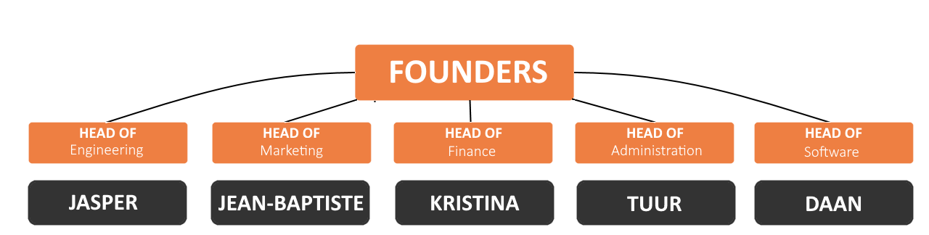

## Personnel description

***Jasper Desnyder - Head of Engineering***

Ever since Jasper has been appointed as head of engineering, he proved every day why he has the role. From day one he has been a great asset to the work done on the chip. He used his incredible creative thinking to make the chip as efficient and secure as possible. After the initial tests, it has been shown that it was already near maximum theoretical efficiency. Despite his age, he has a lot of experience that he has put to good use within the company.

***Jean-Baptiste Van Parys - Head of Marketing***

Jean-Baptiste is a creative and understanding person, with a passion for creating a memorable customer experience. He possesses a deep desire to keep learning new marketing strategies, as well as their application, and knows the customer and the market very well, which makes him the perfect candidate for the head of marketing.

***Kristina Artamonova - Head of Finance***

With an extensive knowledge of accounting and logistics, Kristina was the best fit to do a financial forecast, as well as take the reins in the position of head of finance. With a passion and talent in accounting and financing, she was the best fit for the role.

***Tuur Delacroix - Administration***

Tuur has shown a high level of professionalism while working on his normal duties, and soon he was appointed as head of administration. Every little detail is worked out to perfection so that every single staff member can get satisfaction from it. Since his appointment, the organisation has only been making progress.



***Daan De Waele - Head of Software***

Daan is a creative person with a problem-solving mindset. These are the qualities that make him a good programmer. That, together with his leading personality, made him best qualified to be the head of Marsonality’s software.

## Open positions

Currently Marsonality is in the hatching stage of a beast to grow as big as T-Rex, so the company structure is kept small. Surely with time and growth, Marsonality expects to hire more permanent staff to take in the positions for Human resources, Cybersecurity, Research and many more to grow and improve the experience for both the customers and employees alike.

# RISK MANAGEMENT

|  |  |  |  |
| --- | --- | --- | --- |
|  | **Likelihood Low/Mid/High** | **Impact Low/Mid/High** | **Mitigation Strategies** |
| **System failing to boot and apply traits** | **Low** | **High** | 24/7 live monitoring of bugs and abnormalities in the deployment system. Continuous backup. Use the backup system in case of full shutdown of main services. |
| **User trait database breach** | **Low** | **Low** | 3FA identification to access.  Have a honeypot database tracing the possible hackers. |
| **Client list database breach** | **Low** | **Mid** | 3FA identification to access.  Have a honeypot database tracing the possible hackers. |
| **Hacking and changing traits** | **Mid** | **High** | Prior warning of disabling and banning from the service as well as transferring the hacker data to hitmen. Temporary pause of services to establish the culprit. |
| **Electrical storm damaging the chip** | **High** | **High** | No prevention. Replace the chip for free after being scanned as having a faulty one. |
| **Chip overheating from too many traits** | **Mid** | **Mid** | Design the chip with heat protection and cooling, so it can never overheat. Encourage to not overload with traits |
| **Chip being stolen/removed from a user without agreement of user or company** | **Low** | **High** | Connect Marsonality with MarsID specifically so the traits are applied to the ID, not the physical person. |

# STRATEGIC PARTNERSHIPS

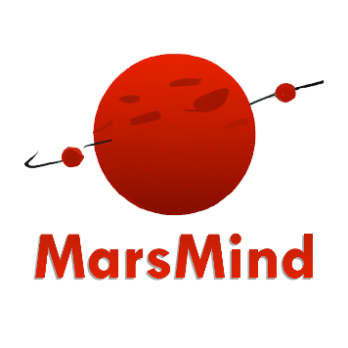Technological partnership with MarsMind - collaboration with mental health application. To mutually exchange information on mental health of our customers as well as MarsMind scans of the citizens.

MarsMind has kindly partnered with us to provide the data on our customers in terms of their mental state, their capabilities as well as any disability information, so Marsonality can make educated decisions on who our future customers will be. Marsonality will also be advertised as a suggestion if people are looking to improve themselves or in case they are not feeling up to the standard of their surrounding community.

Marsonality in turn has included the annual price of the data information in the Research & Development financial plan.

# MARKETING AND SALES

## Marketing website

To provide martians with enough information, we have a marketing website online that includes a brief representation of who we are.

This website can be reached at: <https://marsonality.online/marketing>

## Various aspects

The following parts will describe the aspects who affect our marketing and sales.

### Customer

The core service of Marsonality is adding traits to a person. The addition of traits or mixes of them are solely focused on how the customer would like to have live their life, from a list of 600 traits (so far) to purchase, a person may unlock a profile and add any trait they would like to themselves, or if they unlock more profiles with more slots for traits, have a mix of traits active, so they can customise their own life and their approach to things on their own terms.

Our software provides a list of traits to pick and choose from, along with their description as well as a free first personality scan. From the initial scan , the customer’s initial traits are unlocked for free, as well as a base profile. The first profile would have to be purchased, which will unlock their first slot to buy a trait and apply to their life.

With our software comes the 24/7 risk assessment and management to make the transitions of profiles smooth and without any interruption, Marsonality’s top security is always on the watch for any bugs in the system as well as physical servers to watch out for any disruptions.

Additionally, with constant research into mental health through surveys and MarsMind partnership, Marsonality is always on top of the game when it comes to any new arising traits.

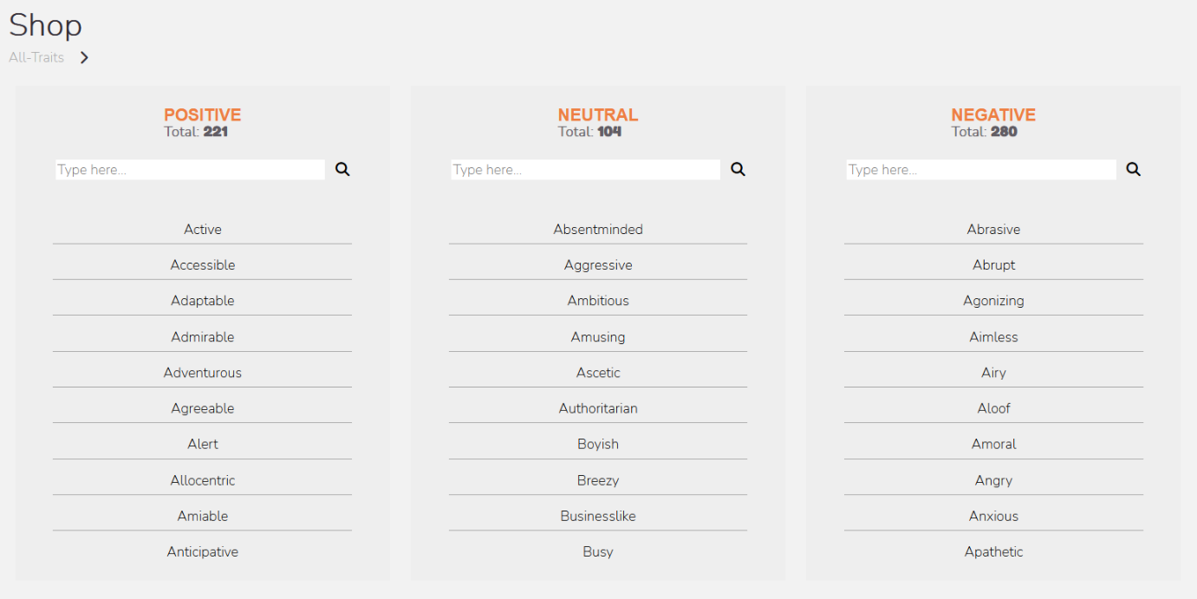

Figure 1: Layout for choosing a trait in the trait shop

### Cost

The costs for our app are based on two factors: Cost-based and value based pricing.

We at Marsonality have calculated our expenditure and based on all the factors presented in the financial report, it is safe to assume that the overhead costs may only rise in terms of more investment into research and development of traits and personalities as well as acquiring any competing firms that may arise.

Below is the financial table showing the costs of running the business in the first 6 years until successful profit flow.

|  |  |  |  |  |
| --- | --- | --- | --- | --- |
| **FIXED COSTS** | **in MarsCoin** |  | **VARIABLE COSTS** |  |
| **Operating Expenses** |  | Furniture, Hardware, software | **32000** |
| Accounting and Legal | **62,000.00** | Gifts given | **4000** |
| Advertising | **12,000.00** | Other | **4000** |
| Insurance | **10,000.00** | Total non-recurring expenses | **40000** |
| Maintenance | **3,000.00** |  |  |
| Office supplies | **12,000.00** | **Total Costs** | **567,150.00** |
| Payroll | **222,950.00** |  | |
| Rent | **65,000.00** |
| Utilities | **6,000.00** |
| Web hosting and domains | **1,200.00** |
| R&D | **83,000.00** |
| Other | **50,000.00** |
| **Total Operating Expenses** | **527,150.00** |
| Conversion rate | **1(eur)=1(MC)** |
| Weeks on Mars in a year | **98** |

Value-based pricing is the second most important thing to Marsonality as it is solely based on pleasing the customer and bringing the most effective product, whether it’s a single person buying for themselves, or a company buying in bulk for their employees. We have conducted a survey with both customer groups and have worked out the most optimal pricings for our products and services.

### Communication

Planning ahead for the technological future, Marsonality has taken into account that the advertisement needs to be relevant more than persistent. The company will be advertised through advice of our partners, as a gentle suggestion to improve their life, as well as at places of work and recreation.

Advertisements will be placed in multiple appropriate places so as not to block the view, but to have a slight subliminal effect, at places of work, ads will be aimed more for productivity, at places of management, ads will be more aimed to adjust their subordinates, advertisements in places of recreation will be aimed to be more humorous or relaxing in nature.

Additionally, taking into account that there is no privacy on Mars, people are free to share their Marsonality profiles as well as see other people's profiles that they could potentially want to be like and emulate.So for example, celebrities or influencers could potentially share their profiles and their fans may want to emulate them and do the same.

### Convenience

Finally, our company is here to make the lives of people easier, this would also reflect in the convenience of acquiring our product as well as simple use and intuitive design. Marsonality is open to any suggestions and constructive criticism to improve the use of the app.

To have the Marsonality chip, one simply needs to make an online appointment to come to our offices, so they can get their personality scan, and if they would like, install a chip the size of a rice grain in their cranium to apply their first unlocked and active profile.

The trials of installation have been tested and were successful in the body not rejecting a foreign item, as it is simply installed into the skin like a dermal piercing, and to add the cherry on the top, for the inconvenience of being pricked, the procedure is done free of charge, and the person at the end of the procedure gets aftercare leaflet.

# FINANCIALS

## Preface

The calculation has been chosen to see the rise of profits in year 5, after investing into research more and to show the continuation of profit going forward.

The timeline has been picked from the calendar year of mars, which in total is 668 days. Mars has 4 seasons just like Earth, but more weeks and months, which we do not have names for (yet). So the timeline has been divided into seasonal quarters.

## Annual prediction and plans

### Year 1

Invest into marketing and selling the product, make statistics of the addiction caused by the product each quarter. Make the holiday sales around the final quarter of the year.

### Year 2

Compile data of the users, tendency for addiction and change of traits as well as likelihood of buying traits/profiles before holidays.

### Year 3

Introduce selling traits and profiles in bulk to businesses. Compile statistics for improvement at places of work. Continue with holiday sales to both regular customers as well as businesses.

### Year 4

Invest into more research of more traits and marketing to businesses.

Continue with holiday sales, implement discounts for bulk buying.

### Year 5

Continue with research and development of new traits, implement selling in bulk to regular customers as well as businesses.

|  |  |  |  |  |
| --- | --- | --- | --- | --- |
| **EXPENSES** |  |  | **FUNDING** |  |
|  |  |  |  |
| **FIXED COSTS** | **in MarsCoin** | **CURRENT ASSETS** |  |
| **Operating Expenses** |  | Cash in hand | 65,000.00 |
| Accounting and Legal | 62,000.00 | Crowdfunding | 50,000.00 |
| Advertising | 12,000.00 | Venture capital | 0.00 |
| Insurance | 10,000.00 |  |  |
| Maintenance | 3,000.00 | Total Assets | 115,000.00 |
| Office supplies | 12,000.00 |  |  |
| Payroll | 222,950.00 | **PRICING** |  |
| Rent | 65,000.00 |  |  |
| Utilities | 6,000.00 | Profile 2 | 200.00 |
| Web hosting and domains | 1,200.00 | Profile 3 | 400.00 |
| R&D | 83,000.00 | Profile 4 | `= Profile 3 * 2 and so on |
| Other | 50,000.00 | Swapping profiles | 5.00 |
| **Total Operating Expenses** | **527,150.00** | Swapping traits | 5.00 |
| Conversion rate | 1(eur)=1(MC) | Trait | 140.00 |
| Weeks on Mars in a year | 98 |  |  |
|  |  | **DATE RANGE** |  |
| **VARIABLE COSTS** |  |  |  |
| Furniture, Hardware, software | 32000 | Martian Annual quarter | Sols |
| Gifts given | 4000 | Quarter 1 | 194 |
| Other | 4000 | Quarter 2 | 178 |
| Total non-recurring expenses | 40000 | Quarter 3 | 142 |
|  |  | Quarter 4 | 154 |
| **Total Costs** | **567,150.00** |  | 668 |
|  |  |  |  |
| Expenses Q1 | 153,094.46 | Revenue Q1 | 10,200.00 |
| Expenses Q2 | 140,468.11 | Revenue Q2 | 34,000.00 |
| Expenses Q3 | 112,058.83 | Revenue Q3 | 47,600.00 |
| Expenses Q4 | 121,528.59 | Revenue Q4 | 73,100.00 |

|  |  |  |  |  |
| --- | --- | --- | --- | --- |
|  | **Year 1** |  |  |  |
|  | **Q1** | **Q2** | **Q3** | **Q4** |
| **Gross revenue** | 10,200.00 | 34,000.00 | 47,600.00 | 73,100.00 |
| **Costs** | 193,094.46 | 140,468.11 | 112,058.83 | 121,528.59 |
| **Profit** | -182,894.46 | -106,468.11 | -64,458.83 | -48,428.59 |

|  |  |  |  |  |
| --- | --- | --- | --- | --- |
|  | **Year 2** |  |  |  |
|  | **Q1** | **Q2** | **Q3** | **Q4** |
| **Gross revenue** | 83,900.00 | 75,400.00 | 92,400.00 | 133,200.00 |
| **Costs** | 153,094.46 | 140,468.11 | 112,058.83 | 121,528.59 |
| **Profit** | -69,194.46 | -65,068.11 | -19,658.83 | 11,671.41 |

|  |  |  |  |  |
| --- | --- | --- | --- | --- |
|  | **Year 3** |  |  |  |
|  | **Q1** | **Q2** | **Q3** | **Q4** |
| **Gross revenue** | 160,400.00 | 174,000.00 | 187,600.00 | 262,400.00 |
| **Costs** | 153,094.46 | 140,468.11 | 112,058.83 | 121,528.59 |
| **Profit** | 7,305.54 | 33,531.89 | 75,541.17 | 140,871.41 |

|  |  |  |  |  |
| --- | --- | --- | --- | --- |
|  | **Year 4** |  |  |  |
|  | **Q1** | **Q2** | **Q3** | **Q4** |
| **Gross revenue** | 269200.00 | 350800.00 | 361600.00 | 475200.00 |
| **Costs** | 153,094.46 | 140,468.11 | 112,058.83 | 121,528.59 |
| **Profit** | 116105.54 | 210331.89 | 249541.17 | 353671.41 |

|  |  |  |  |  |
| --- | --- | --- | --- | --- |
|  | **Year 5** |  |  |  |
|  | Q1 | Q2 | **Q3** | Q4 |
| **Gross revenue** | 543200.00 | 577200.00 | 582600.00 | 650600.00 |
| **Costs** | 236094.46 | 223468.11 | 195058.83 | 204528.59 |
| **Profit** | 307105.54 | 353731.89 | 387541.17 | 446071.41 |

|  |  |
| --- | --- |
| **Break-even point** | **Year 2 Q4** |
| Gross revenue | 133,200.00 |
| Costs | 121,528.59 |
| Profit | 11,671.41 |

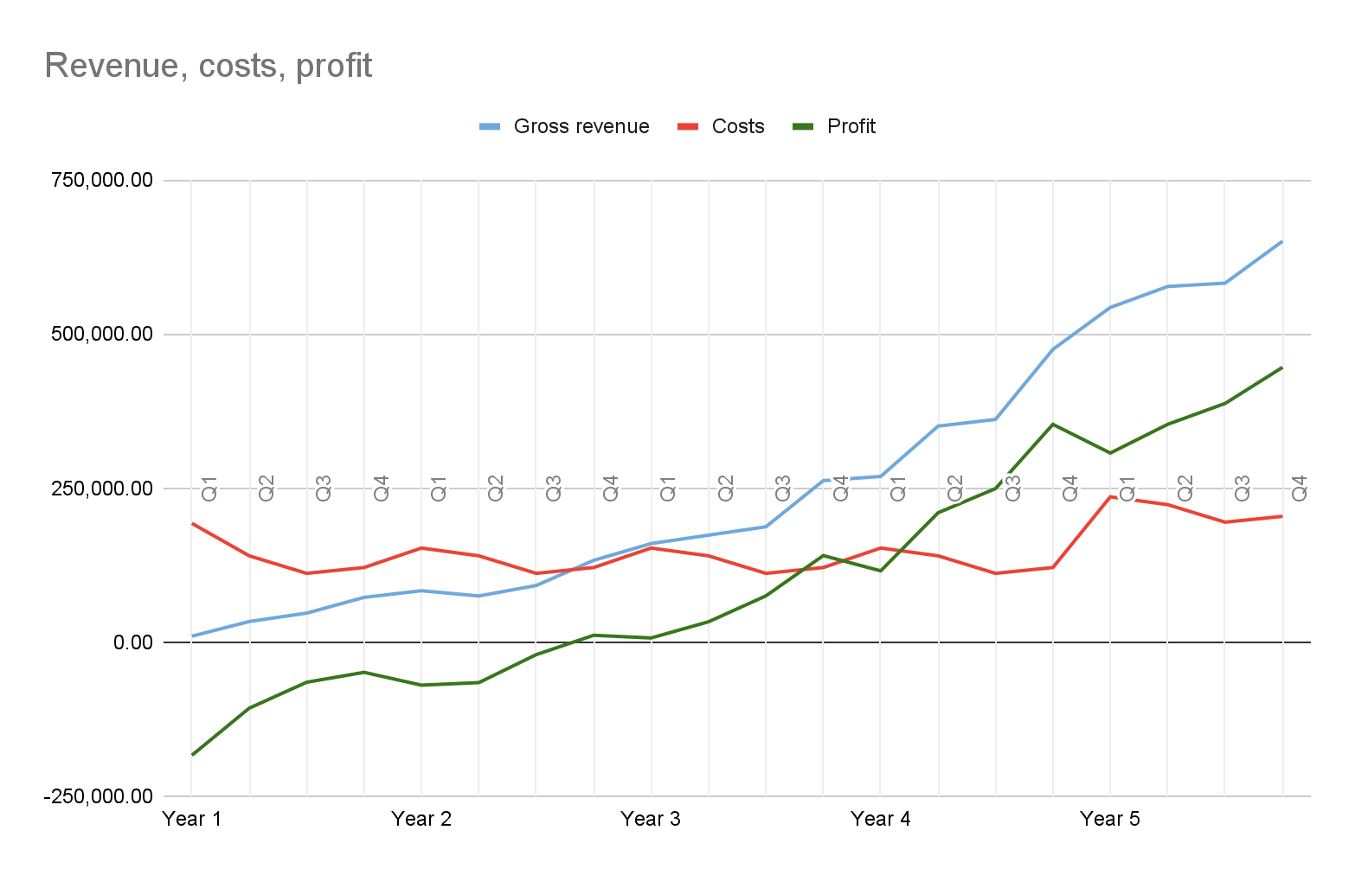

Figure 2: Revenue, costs and profit graph

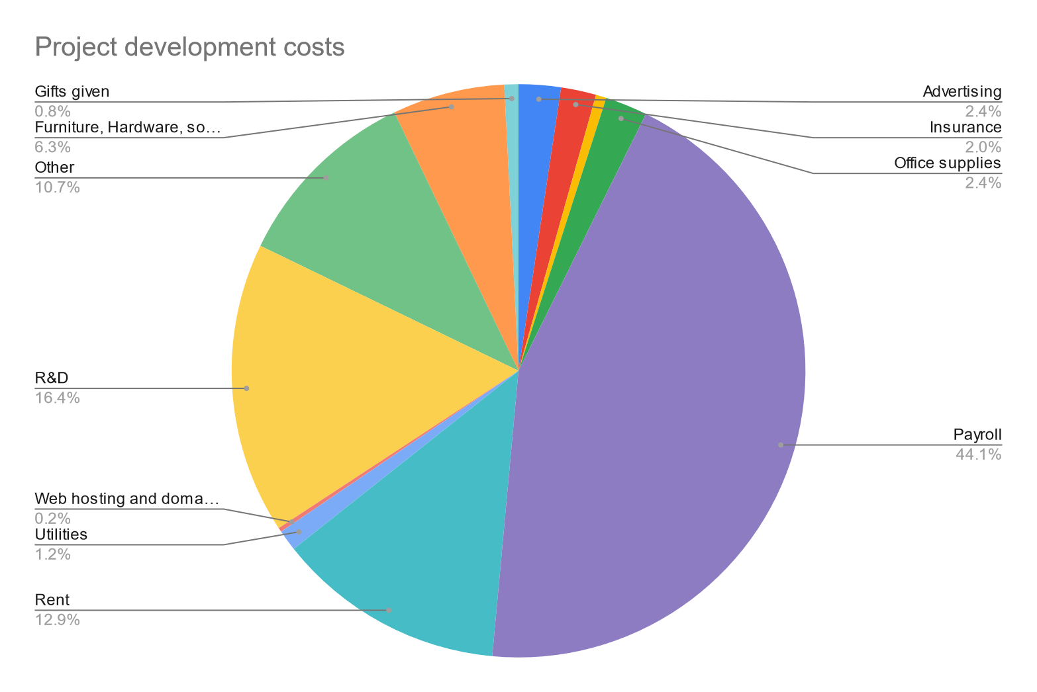

Figure 3: Development costs graph

# ETHICAL DECISIONS

As with everything in life, we had to make some ethical decisions in the development of our product.

First off, we need to take into account that the very rich people of Mars will have an unfair advantage when it comes to how many profiles (which also directly translate to the amount of traits) one can have. We decided to go with an exponentially growing price for profiles both so that almost anyone can afford at least 1-3 profiles and so that the really rich still have to think carefully about how much they actually want to pay to be “better” than others.

To put it into perspective, the tenth profile (with 10 traits) costs 102,400 MarsCoin and by the time they get to the 20th it’s 104,857,600 MarsCoin. We expect this to keep the really rich people from trying to feel superior but even if that does not discourage them, we still monitor the big buyers to ensure that they are not using our product for unethical purposes.

But what is arguably more important is that our product mustn't do any harm to the physical brain of the user. Over the past 50 years, a significant amount of research has been conducted on the brain. Because of that we are able to manipulate the brain waves to change people’s personality. However changing these can be quite a burden on the brain so if we are not careful it could possibly lead to brain damage. This is quite a big risk, but with our technology you don’t run any risk, because our engineers made a safe chip deactivation process.

This is where an ethical question comes up. Is it responsible to let our customers use our product if changing a personality could cause brain damage in a worst case scenario? The answer is that in normal circumstances it might not be, but our profile switching system slowly changes the brain waves, in a way that will never cause harm to the user. So our product is virtually risk-free.

# BUSINESS MODEL CANVAS

## Customer

### Segments

We are seeking regular Martians aged 25 and over to participate in our program.

The requirement for participation is that the brain must be fully developed.

If you have struggled with low self-esteem or insecurity, we encourage you to consider participating in our program. We also welcome people with disabilities and non-violent mental disorders to apply.

Our program is not only beneficial for individual participants, but also for businesses and research and medical entities focusing on mental health. These organizations can pay for access to data provided by brain scans and data on the customer base and trait use.

By participating with Marsonality, you can not only improve your own mental health, but also contribute to the advancement of mental health research and treatments.

### Relationships

We value customer relationships and strive to create a sense of community among our users.

One way we do this is by allowing friends to share their data with each other, fostering a sense of connection and support.

We also offer live push notifications to keep our customers informed and up-to-date on the latest updates and features.

By using our chip and creating usage statistics, customers can track their progress and see how they compare to others in the community.

Overall, we believe that strong customer relationships and a sense of community are key to creating a positive and successful user experience.

## Channels

At Marsonality we use a variety of channels to advertise and promote our product.

One way we advertise is by placing ads at the Space station, as well as at main places of work, travel, and relaxation.

We also offer free scans to attract new customers and give them a taste of what our product has to offer.

In addition to traditional advertising methods, we rely on customer reviews and recommendations to spread the word about Marsonality.

We encourage both users and businesses to leave reviews of our product online and offline.

We also provide customer support while on Mars and for customers with an active chip.

Our support team is available to answer any questions or concerns and ensure that our users have a seamless experience with Marsonality.

Finally, we prioritize user experience and make sure that our product is easily accessible through an intuitive UI and convenient wristband.

## Revenue streams

One way we generate revenue is by selling profile blocks and individual traits to users. Customers can also purchase profiles and traits in bulk for a discounted price.

We also sell user data and research on our customer base to businesses and research organizations.

This allows us to not only generate income, but also contribute to the advancement of knowledge and understanding in the field of mental health.

In addition to these regular revenue streams, we offer sales and discounts around holidays to encourage customer engagement and loyalty.

Finally, we charge licensing fees for use of our product, which is available only to those on Mars.

Overall, our diverse revenue streams allow us to continue providing high-quality service and support to our valued customers.

## Key activities

One of our main focus areas is research and development of traits and their implementation in our product.

We are constantly exploring new ways to enhance the user experience and provide valuable insights and tools for personal growth and development.

In order to ensure the smooth operation of our product, we also engage in regular maintenance of our profile and trait databases.

This includes activating and deactivating profiles as needed, as well as conducting quality control checks on released traits.

Additionally, we prioritize the maintenance of our servers and their backups to ensure the security and availability of our product.

Overall, our key activities focus on delivering a high-quality and reliable product to our customers.

## Key resources

Our primary resource is our team of developers and researchers who work tirelessly to create and improve our product.

Their knowledge, skills, and expertise are invaluable in ensuring the success and innovation of Marsonality.

In addition to our people, the Marsonality software application is a key resource for our product.

This application serves as the platform for our users to access and utilize the various features and tools provided by Marsonality.

We also rely on physical resources such as microchips and satellite connections to enable the functionality of our product.

These resources allow us to provide a seamless and reliable user experience for our customers.

Finally, we have a range of intellectual resources including patents, copyrights, and customer databases that protect and enhance the value of our product.

## Key partners

### MarsMind

A company that provides marketing and advertising services on our behalf to their user base. This partnership allows us to reach a wider audience and grow our customer base.

### 3rd Party chip storage and logistics

We also work with a third-party chip storage and logistics company to ensure the efficient and secure handling of our product. This partnership allows us to focus on the development and innovation of Marsonality, while outsourcing the logistics and storage aspects to a reliable and trusted partner.

## Cost structure

Our cost structure consists of both fixed and variable expenses.

Our **fixed** **costs** include accounting, legal, insurance, wages, maintenance, rent, utilities, hosting, domains, and satellite connection fees. These costs remain relatively constant regardless of the level of production or sales.

On the other hand, our **variable** **costs** are expenses that vary based on the level of production or sales. These costs include utilities, hardware, advertising, and office supplies.

## Value propositions

In terms of value propositions, our company offers a range of products and services. One of the main benefits of using Marsonality is the ability to add and change profiles and traits, allowing users to tailor their experience and focus on areas of personal growth and development.

Additionally, by increasing the number of profiles and traits available, we provide a wider range of tools and resources for our customers.

Another key proposition to the value of Marsonality is the potential for improvement in self-worth and overall well-being. By providing personalized assessments and tools for self-improvement, we aim to help our users feel more confident and fulfilled in their lives.

We also offer a free assessment of personality to help users get started on their journey with Marsonality.

Furthermore, as the founder in the field of personality enhancement, we offer a unique and unparalleled service with no competition in terms of the quality and effectiveness of our product.

In addition to these benefits, we offer discounted pricing for bulk purchases by large and small employers.

We also prioritize customer care by providing cooldowns and warnings of use to ensure the safe and responsible use of our product.

Overall, our key propositions aim to provide a comprehensive and personalized experience for our customers to help them achieve their goals and improve their well-being.

# USER TESTING

All our schematics are designed bases on several user tests executed by technical and non-technical persons.

Please find them

# APPENDICES

## Business Model Canvas

## Schematics

We reference to our online version to see all our schematics for the best experience.

<https://marsonality.online/schematics>

# SOURCES

[1] SVGRepo, Images used in documentation, <https://www.svgrepo.com/>

[2] mit.edu, All traits used in our application, <http://ideonomy.mit.edu/essays/traits.html>

[3] Merriam, All trait descriptions of the traits used in our application, <https://www.merriam-webster.com/>

[4] OpenPlanetary, Map used on our application, <https://www.openplanetary.org/opm-basemaps/opm-mars-basemap-v0-2>